Lab 10
Sabina Rasheed | 22k-5198

Q no 1 :

Tell me konsi example krni hai from manual??

Q no 2 :

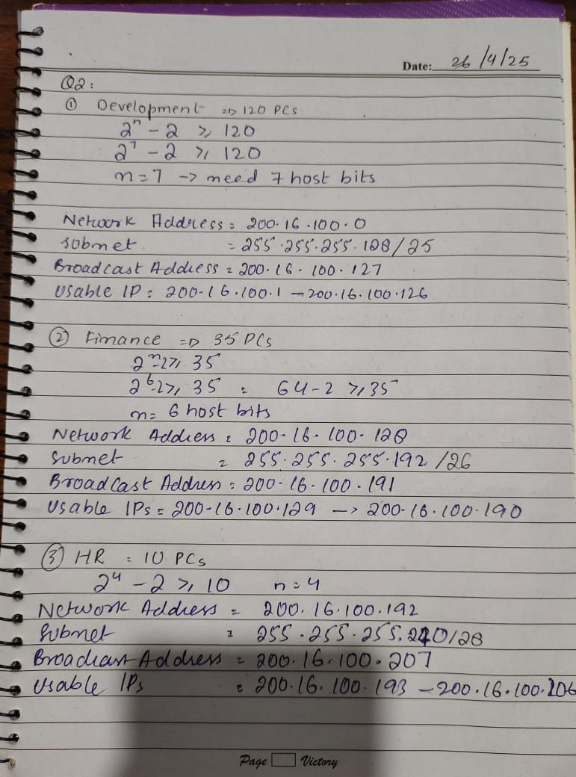

Q no 3 :

CS-Router:

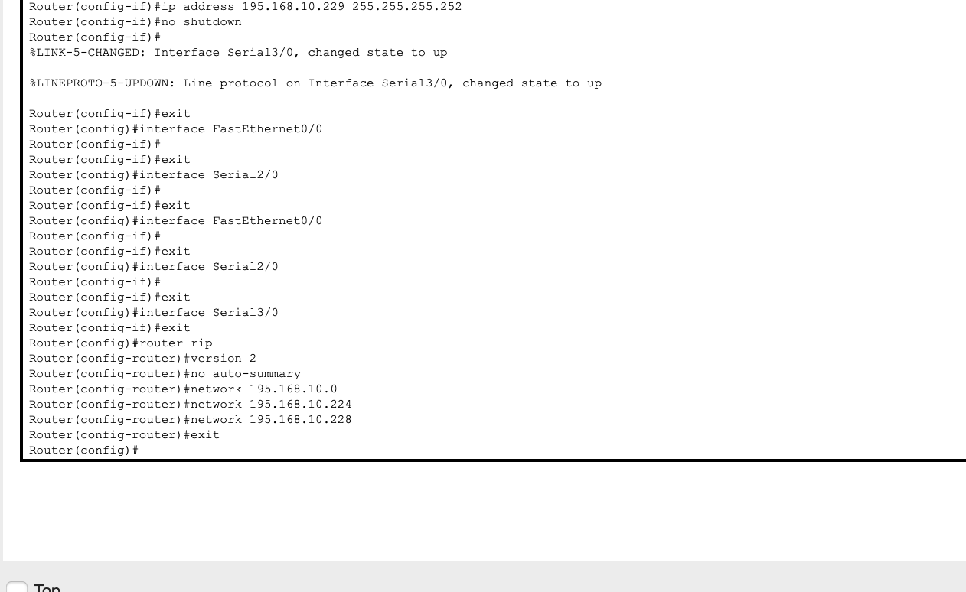

EE-Router :
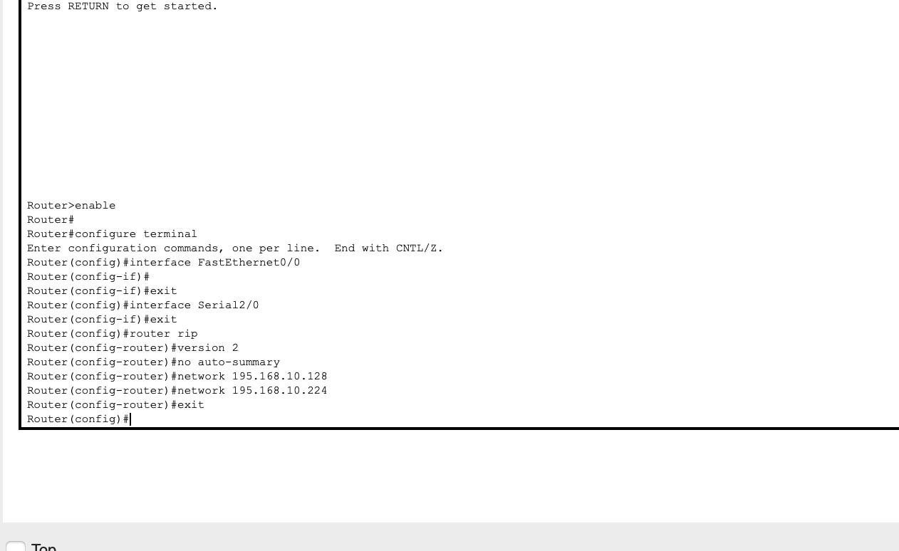

BBA-Router :

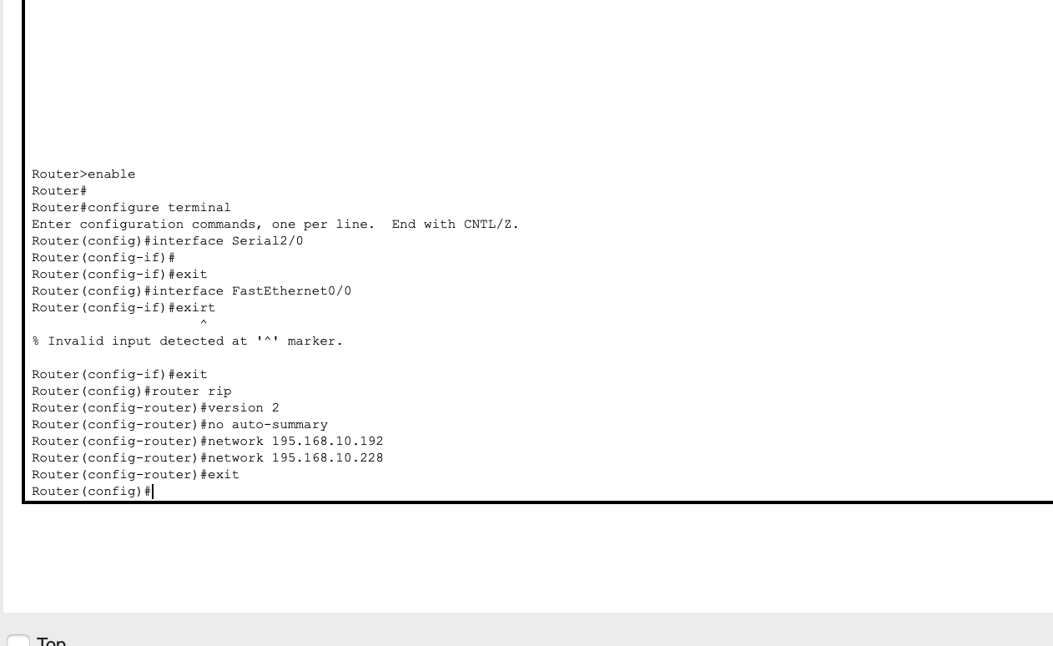

PCs in different networks can ping each other due to RIP
